[ TITTLE ] – PUT TITTLE HERE COLOR BLACK
The primary objective of the LMD-PESO Online Employment System is to develop web-based employment platform that connects jobseekers with local employers. The system aims to empower Marinduqueños with modern tools for profile management, job matching, and application tracking while providing employers with efficient applicant screening and vacancy management capabilities. The system is designed to implement an intelligent job matching algorithm that analyzes skills, education, and experience to provide accurate job recommendations for jobseekers and qualified applicant lists for employers. It aims to establish a centralized data management system that generates real-time labor market reports, tracks placement statistics, and automates government compliance reporting including SPRS requirements. Additionally, the system seeks to provide a secure, mobile-responsive interface with role-based access control that ensures reliable 24/7 availability and maintains comprehensive audit trails for all employment facilitation activities.
Functional Requirements
Module 1: User Registration and Account Management
- The system shall user to register online as either a Jobseeker or an Employer.
- The system shall provide role-based access control, defining distinct permissions and interfaces for Jobseekers, Employers, and Administrators.
- The system shall allow all users to manage their profiles, including viewing, editing personal and account information.
- The system shall allow Jobseekers and Employers to delete their accounts, subject to data retention policies.
- The system shall include verification and activation process of account checked by an admin.
- The system shall provide "forgot password" option for users to reset their credentials.
Module 2: Jobseeker Module
- The system shall allow jobseekers to create and manage a detailed professional profile, including personal information, skills, education, and work experience.
- The system shall allow jobseekers to upload, update, and store multiple versions of their resume/CV.
- The system shall provide an option for jobseekers to have the system auto-generate a resume based on their profile data.
- The system shall allow jobseekers to select and save job preferences (e.g., location, industry, job type).
- The system shall provide a comprehensive application history tracker, allowing jobseekers to view the status (e.g., pending, viewed, shortlisted, rejected) of all jobs they have applied for.
Module 3: Employer Module
- The system shall allow employers to create and manage a detailed company profile.
- The system shall allow employers (including those outside the immediate LMD-PESO sphere) to post, update, and manage job vacancies.
- The system shall allow employers to view, search, and filter the list of applicants for their job postings.
- The system shall allow employers to update the status of applicants (e.g., shortlist for interview, hire, reject) and communicate decisions through the system.
Module 4: Enrollment and Verification System
- The system shall provide an online submission interface for employers to submit required documents for verification.
- The system shall feature an automated document checklist, guiding employers on what to submit.
- The system shall provide administrators with a dedicated interface to verify submitted documents and approve or reject employer registrations.
- The system shall allow admins to send rejection notices with specific remarks, enabling employers to correct and resubmit their applications.
Module 5: Automated Job Matching System
- The system shall automatically match jobseekers to job vacancies based on an algorithm that analyzes skills, educational attainment, and work experience.
- The system shall generate a ranked list of suitable job recommendations for the jobseeker.
- The system shall also provide employers with a list of the most qualified applicants for their specific job postings, ranked by their match percentage, using an enhanced semantic filtering algorithm.
Search and Filtering System
- The system shall provide search function for visitors, jobseekers, and employers to browse:
    - Finding jobs (local, regional, overseas)
    - Exploring training programs (TESDA, DOLE, other agencies)
    - Accessing government employment services (livelihood grants, internships, apprenticeships)
    - Getting labor market insights (which industries are hiring, what skills are needed)
- The system shall allow users to filter search results by multiple criteria, including location, industry, skills, salary range, and job type.
- The system shall support keyword-based searching across job titles and descriptions.
Module 7: Notification System
- The system shall send real-time notifications to users for key events, including: account approval, new job matches, application status changes, and interview schedules.
- The system shall notify employers when a new application is received for their job postings.
- The system shall make notifications accessible within the user dashboard and, optionally, via email or push notification.
Module 9: Admin Dashboard
- The system shall provide a centralized admin dashboard for managing all system users and content.
- The system shall allow the admin to approve or reject new employer registrations and job postings.
- The system shall maintain detailed system activity logs and audit trails for all user actions to ensure security and accountability.
- The system shall allow the admin to monitor user activities and overall system health.

Non-Functional Requirements
Non-functional Requirements outline the qualities and characteristics of the system to ensure its overall effectiveness and performance.
A. Usability – The system shall feature a simple, clean, and intuitive user interface to accommodate users with varying levels of digital literacy, including jobseekers, employers, and government staff. Navigation shall be consistent and logical across all modules.
B. Accessibility – The system shall employ a mobile-responsive design to ensure full functionality and ease of use across all devices, including desktops, tablets, and smartphones. The interface shall support multi-language options and include clear visual elements, simple forms, and easily accessible user guides and FAQs.
C. Security – All user account data, particularly personal information, must be securely stored and accessed.
D. Reliability and Availability – The system shall be available online 24 hours per day, 7 days per week, with a target uptime of 99.5%. Automated data backup and recovery functions must be in place to prevent data loss and ensure business continuity.
E. Performance – The system shall provide fast response times for user interactions, including searching, applying, and report generation. It shall be designed to support a minimum of 1,000 concurrent users without significant degradation in performance. The automated job matching algorithm shall process and return results within an acceptable timeframe.
F. Maintainability – The system architecture must be modular and well-documented, allowing authorized developers and system administrators to easily update content (e.g., job postings, FAQs), configure system settings, deploy bug fixes, and improve features without causing significant downtime or disrupting user experience.
G. Interoperability – The system shall be capable of integrating with external services or APIs (e.g., for skills data enhancement) and shall support the export of reports and data in standard formats (e.g., PDF, Excel) for use with other productivity tools.

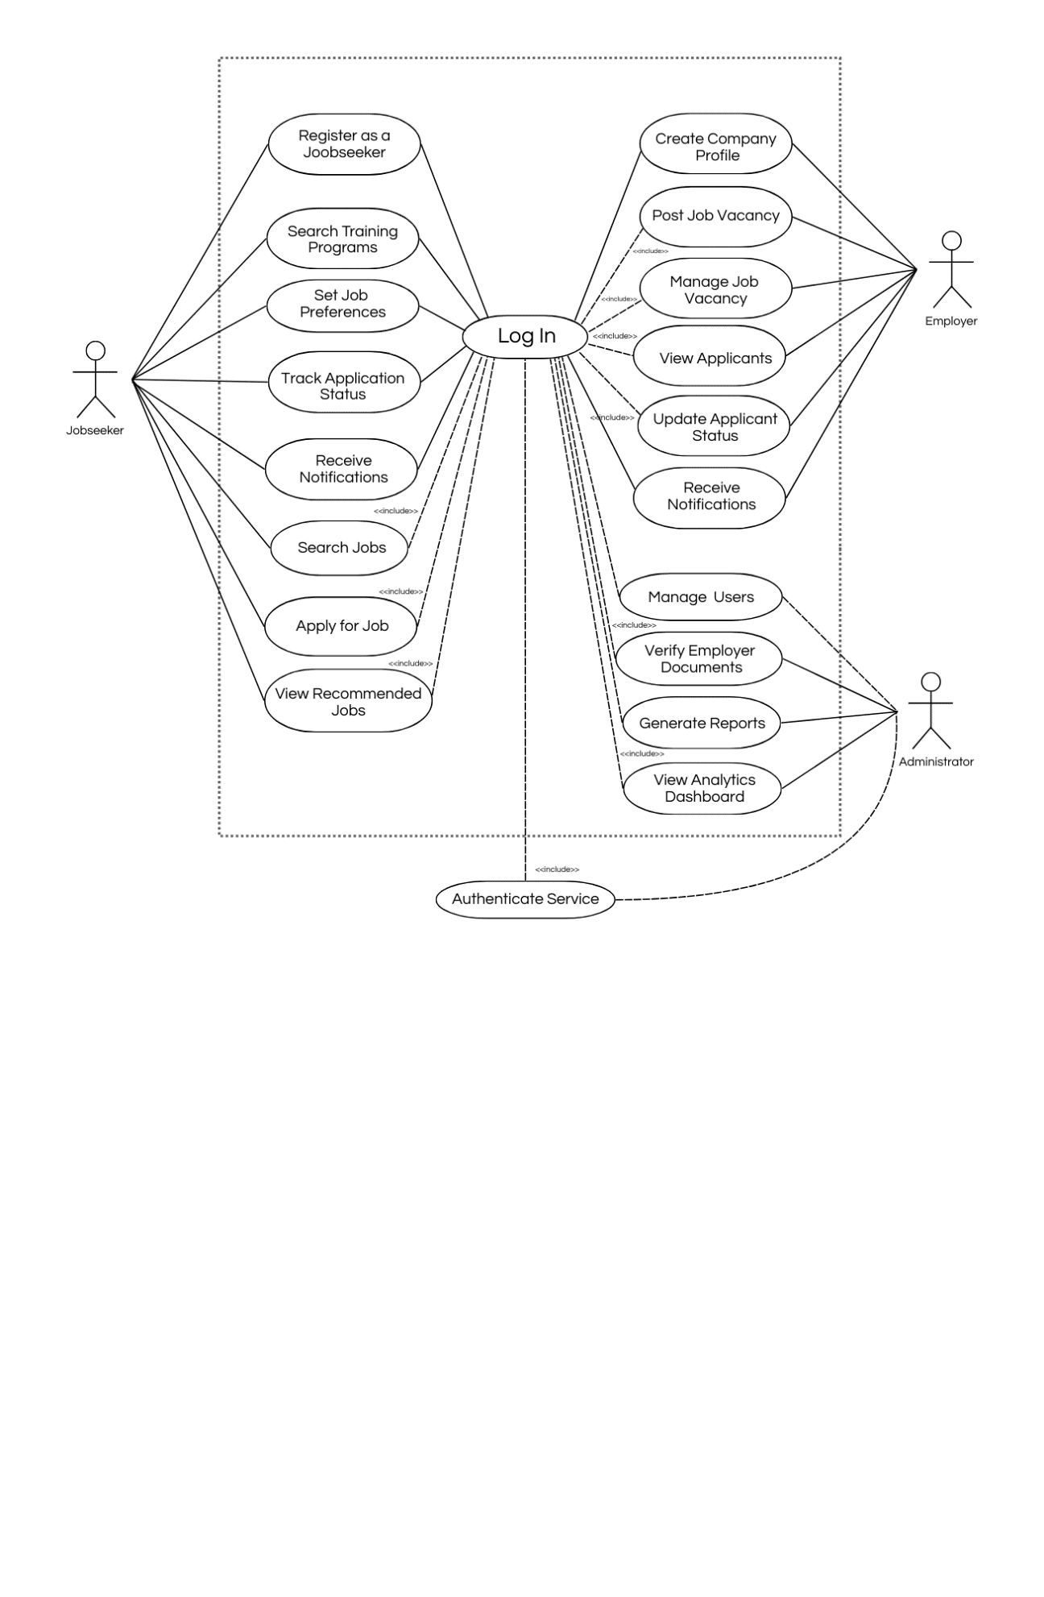
Figure 1: Use-case Diagram of Proposed System

1. System Boundary
The dashed rectangle represents the Online Employment Service System.
All functions inside the box are services provided by the system, while actors outside the box are external users interacting with the system.
2. Actors of the System
The system involves three primary actors:
1. Jobseeker
The Jobseeker is a registered user who uses the system to search and apply for job opportunities.
The jobseeker can perform the following actions:
- Register as a Jobseeker
- Search Training Programs
- Set Job Preferences
- Search Jobs
- Apply for Job
- Track Application Status
- View Recommended Jobs
- Receive Notifications
These features help jobseekers find suitable job opportunities and monitor their job applications.
2. Employer
The Employer represents companies or organizations that use the system to recruit employees.
The employer can perform the following tasks:
- Create Company Profile
- Post Job Vacancy
- Manage Job Vacancy
- View Applicants
- Update Applicant Status
- Receive Notifications
Through these functions, employers can publish job opportunities and manage the recruitment process.
3. Administrator
The Administrator manages and supervises the system.
The administrator is responsible for:
- Managing system users
- Verifying employer documents
- Generate Reports
- View Analytics Dashboard
This ensures that employers are legitimate and that the system operates properly.

3. Log In as the Central Process
The Log In use case is placed at the center of the diagram because it acts as the authentication gateway for most system operations.
Before accessing protected system features, users must first log in to verify their identity.
For example:
- Jobseekers must log in before applying for jobs or tracking applications.
- Employers must log in before posting job vacancies or managing applicants.
- Administrators must log in before managing users or verifying employer documents.
This ensures that only authorized users can access sensitive system functions.
4. Include Relationship (<<include>>)
The <<include>> relationship indicates that a specific use case requires another use case to be executed first.
In this diagram, several functions include the Log In process.
Examples include:
- Apply for Job <<include>> Log In
- Search Jobs <<include>> Log In
- View Job Vacancy <<include>> Log In
- Manage Job Vacancy <<include>> Log In
- View Applicants <<include>> Log In
- Update Applicant Status <<include>> Log In
- Manage Users <<include>> Log In
- Generate Reports <<include>> Log In
- View Analytics Dashboard <<include>> Log In
- Verify Employer Documents <<include>> Log In
This means that the system automatically requires authentication before these actions can be performed.
5. Authentication Service
The Authentication Service is responsible for validating the login credentials of users.
It checks the following:
- Username or email
- Password
- User account validity
Once the credentials are verified, the user is granted access to the system.

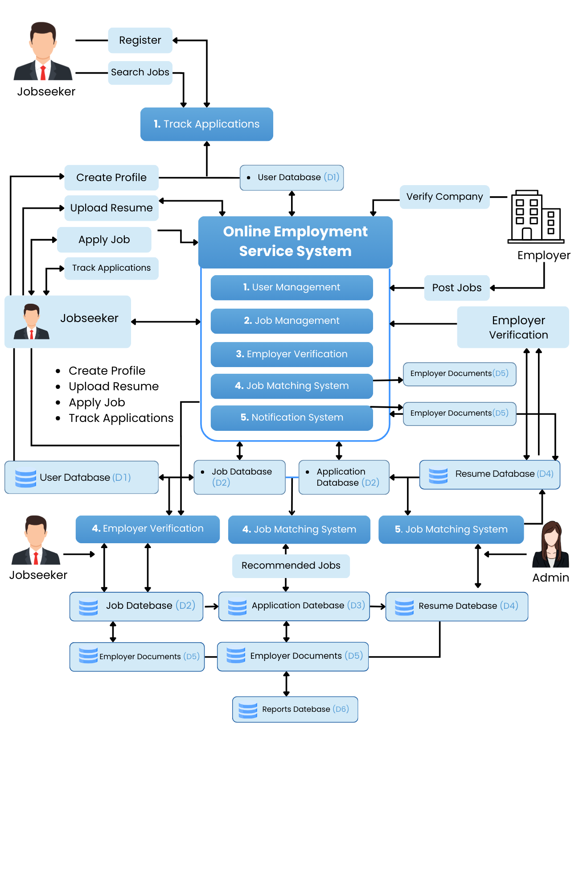
Figure 2: Data Flow Diagram of Proposed System

To be Interviewed:
Person Interviewed: ______________________________________
Position in Organization: __________________________________

Existing System: ____________________________________________________________________________________________________________________________________________________________________________________________________________________________________________________________________________________________________________________________________________________
[ baka may system diagram sila ]

Expenses Yearly of Existing system:__________________________________________________________________________________________________________________________________________________________________________ [ manually or with system ]

Note: need natin ng data na reliable resources

To Do:
1. Letter to Interview
2. Present SRS to be checked and approved
3. Present Use Case Diagram
4. Present A Data Flow Diagram
5. Put this paper in a CICS template paayos ng spacing hah maging formal
6. Update words baka mukhang ai tsaka ung objective na nasa unahan
7. Update or atangalin nay un [ Non-Functional Requirements ]
8. Siguro ay if pede mag pa check kay ser kierven?
9. Proposed new title [ Online Employment of LMD PESO]
10. Let the interview proceed don’t argue or mag talo within the facility maging professional and mag take ng picture contact and ung mga tao na ainterviewhin

